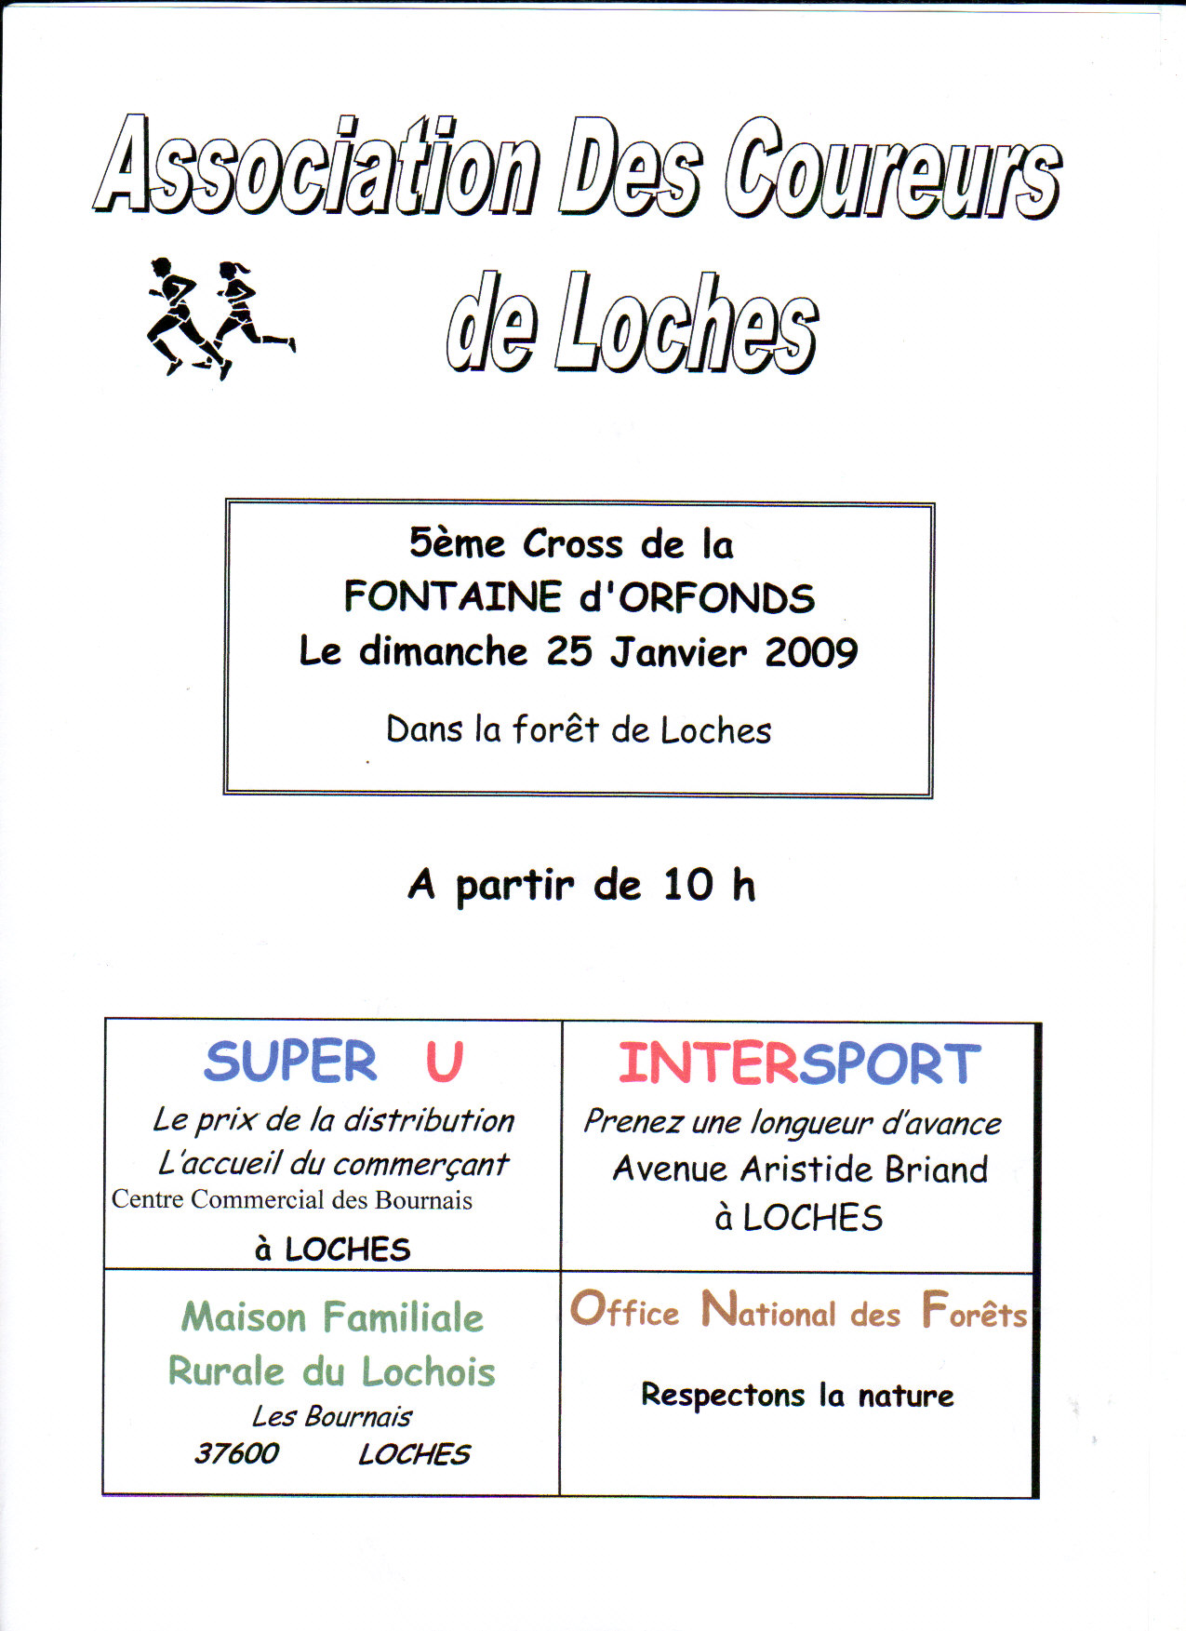
Association des Coureurs
de Loches

Cross du Dimanche 25 janvier 2009

BF - BG - MF - MG | F | BF - BG - MF - MG | Chr : M
8 | 10'41'' | DUJARDIN Matthieu | As Fondettes | 037 | CEN | BEM/96
CF - CH - Cross Court H et F - J à V - | M | CF - CH - Cross Court H et F - J à V - | Chr : M
9 | 16'00'' | BOUCARD Laurent | As Fondettes | 037 | CEN | V1M/61
10 | 16'20'' | MARIN Carine | As Fondettes | 037 | CEN | SEF/72
Résultats Équipes | J à V F et M -
1 | 24pt | AS FONDETTES | 3 (100), 7 (93), 14 (101)
2 | 31pt | ASSOCIATION COUREURS DE LOCHES | 8 (1527), 10 (1525), 13 (166)

Résultats Équipes | J à V F et M - ES-SE M -
1 | 24pt | AS FONDETTES | 3 (100), 7 (93), 14 (101)
2 | 31pt | ASSOCIATION COUREURS DE LOCHES | 8 (1527), 10 (1525), 13 (166)
Résultats Équipes | J à V F et M - VE M -
1 | 19pt | SAINTE MAURE ATHLETIC CLUB | 1 (1068), 3 (1067), 15 (731)
2 | 31pt | INDRE AC * | 8 (1693), 9 (1689), 14 (1688)
3 | 40pt | AS FONDETTES | 2 (114), 12 (125), 26 (1266)
4 | 43pt | NL | 6 (1703), 10 (1719), 27 (1702)
5 | 68pt | US RENAUDINE ATHLE CROSS | 19 (624), 24 (610), 25 (618)
6 | 104pt | ASSOCIATION COUREURS DE LOCHES | 32 (1537), 35 (1541), 37 (1549)

J à V F et M | M | J à V F et M | Chr : M
20 | 28'48'' | BEJEAULT Richard | As Fondettes | 037 | CEN | V1M/66
21 | 28'54'' | PETITBOUT Julien | As Fondettes | 037 | CEN | SEM/75
31 | 30'42'' | DAUVILLON Emmanuel | As Fondettes | 037 | CEN | SEM/78
38 | 31'49'' | NETTER Denis | As Fondettes | 037 | CEN | V1M/66
47 | 32'57'' | SAULNIER Julien | As Fondettes | 037 | CEN | SEM/81
62 | 35'43'' | POIREAU Didier | As Fondettes | 037 | CEN | V1M/60
67 | 36'32'' | BRIANT Christophe | As Fondettes | 037 | CEN | SEM/73
76 | 38'00'' | MORIN Valery | As Fondettes | 037 | CEN | SEM/73
Résultats Équipes | PF - PG -
1 | 8pt | US RENAUDINE ATHLE CROSS | 1 (568), 3 (569), 4 (1295)
2 | 22pt | ASSOCIATION COUREURS DE LOCHES | 5 (161), 7 (1510), 10 (160)
3 | 26pt | AVENIR AMBOISE ATHLETISME | 2 (226), 6 (225), 18 (235)
4 | 43pt | AS FONDETTES | 9 (71), 15 (67), 19 (64)

Résultats Équipes | PF - PG - PO F -
1 | 8pt | US RENAUDINE ATHLE CROSS | 1 (568), 3 (569), 4 (1295)
2 | 22pt | ASSOCIATION COUREURS DE LOCHES | 5 (161), 7 (1510), 10 (160)
3 | 26pt | AVENIR AMBOISE ATHLETISME | 2 (226), 6 (225), 18 (235)
4 | 43pt | AS FONDETTES | 9 (71), 15 (67), 19 (64)
Résultats Équipes | PF - PG - PO M -
1 | 12pt | ASSOCIATION COUREURS DE LOCHES | 1 (1507), 4 (162), 7 (163)
2 | 20pt | AVENIR AMBOISE ATHLETISME | 3 (247), 8 (239), 9 (242)
3 | 26pt | AS FONDETTES | 5 (78), 10 (85), 11 (87)

PF - PG | M | PF - PG | Chr : M
6 | 5'10'' | DORIOT Antonin | As Fondettes | 037 | CEN | POM/98
18 | 5'32'' | ROPARS Lucas | As Fondettes | 037 | CEN | POM/98
19 | 5'33'' | OLIVEIRA Lou | As Fondettes | 037 | CEN | POF/98
20 | 5'34'' | WALTER Lucas | As Fondettes | 037 | CEN | POM/98
21 | 5'36'' | PILON Matteo | As Fondettes | 037 | CEN | POM/98
22 | 5'37'' | CLAVEAU Francois | As Fondettes | 037 | CEN | POM/98
30 | 6'01'' | LEROUX Clemence | As Fondettes | 037 | CEN | POF/98
34 | 6'16'' | DURENDEAU Simon | As Fondettes | 037 | CEN | POM/99
35 | 6'21'' | GERBIER Maud | As Fondettes | 037 | CEN | POF/99
42 | 7'09'' | LLOVERAS Marine | As Fondettes | 037 | CEN | POF/98
44 | 7'19'' | MONTERRAT Thomas | As Fondettes | 037 | CEN | POM/98
Résultats Équipes | SPF - SPG - EA M -
1 | 14pt | ASSOCIATION COUREURS DE LOCHES | 1 (149), 6 (1500), 7 (1501)
2 | 15pt | AS FONDETTES | 2 (38), 5 (34), 8 (36)

SPF - SPG | M | SPF - SPG | Chr : M
2 | 3'29'' | DUJARDIN Clement | As Fondettes | 037 | CEN | EAM/00
7 | 3'37'' | BOULARD Thomas | As Fondettes | 037 | CEN | EAM/01
11 | 3'41'' | LUSSAUD Maude | As Fondettes | 037 | CEN | MIF/95
12 | 3'41'' | CLAVEAU Emmanuel | As Fondettes | 037 | CEN | EAM/00
14 | 3'47'' | PILON Chiara | As Fondettes | 037 | CEN | EAF/00
17 | 3'50'' | SAVARY Emma | As Fondettes | 037 | CEN | EAF/00
30 | 4'46'' | MAHIEU-BARBIN Donatienne | As Fondettes | 037 | CEN | EAF/01

